**Practical 2 :**

**Creating Amazon EC2 instances with Microsoft Windows**

Step 1. Go to AWS dashboard and select EC2 in compute.

Step 2. Select “Windows 2008 Server Base”

Step 3. Here select the free tier eligible and then Next

Step 4. Configure Instance Details :

No changes are required just proceed to Next : Add Storage

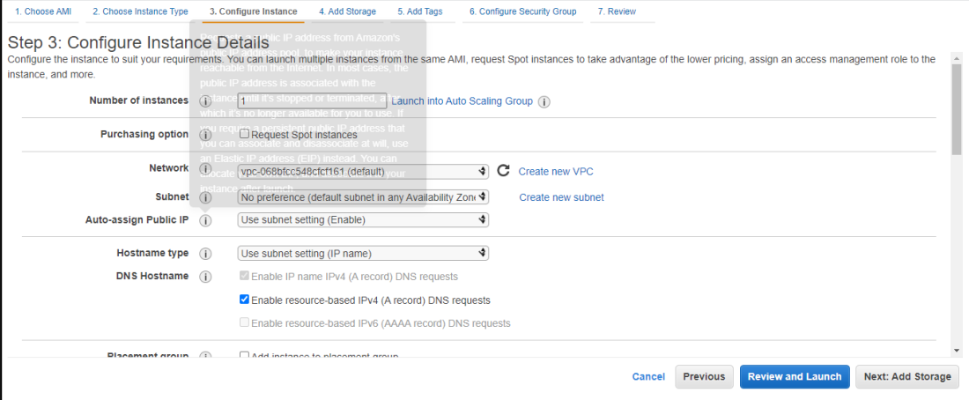

Step 5. Add Storage: -No changes required here but if wanted one can change the storage capacity by changing in the size column

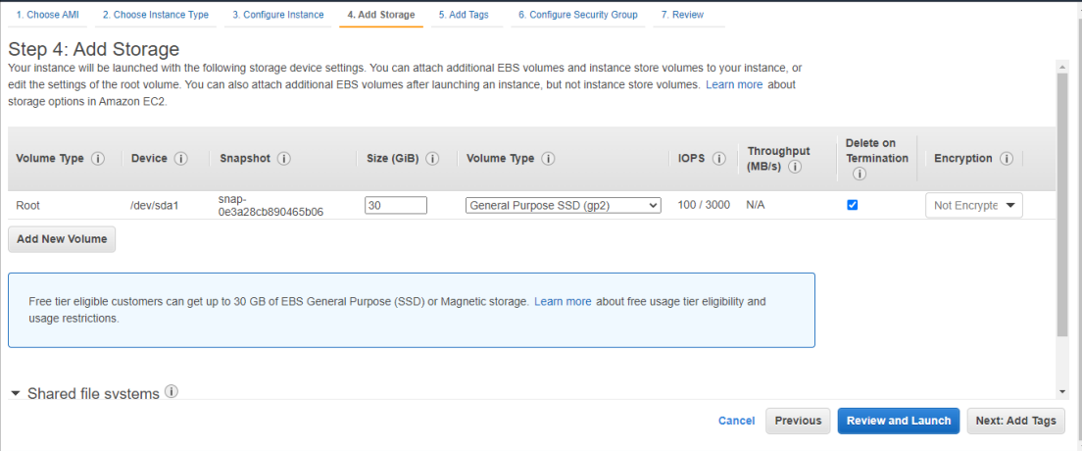

Step 6. Tags: -In key mention anything and in value specify something to identify such as is it recognizable - Click Next: Configure Security Group

Step 7. Configure Security Group - No changes required just proceed towards by clicking on Review and Launch

Step 8. Creating Pair key for Remote Desktop - Go to Dashboard and select the instance which you created just now. –

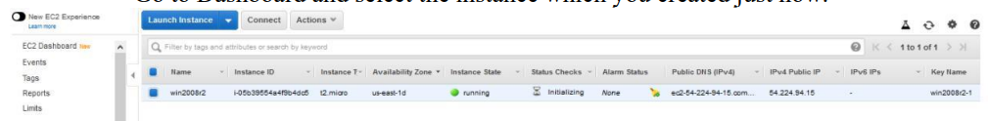

Click on Connect - It will show a Dialog box in which you need to select create new Pair Key. - Mention any key pair name and then download then key pair and save it. - Launch instance.

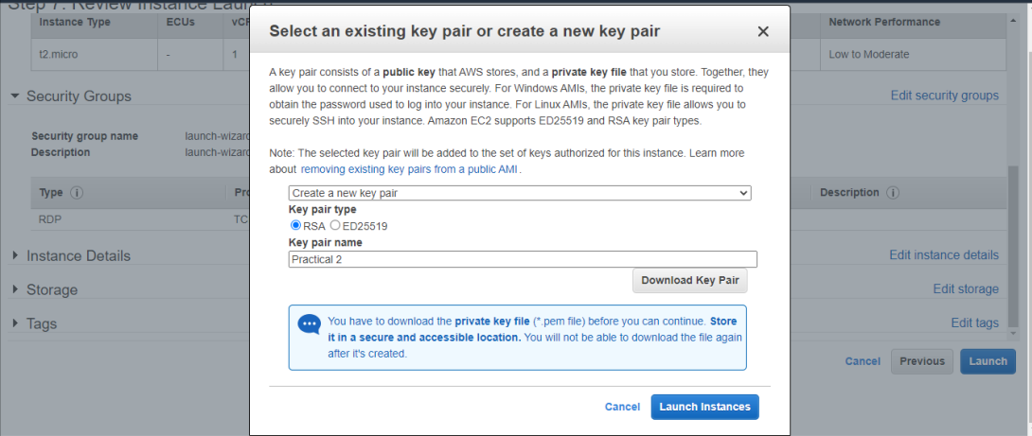

Step 9. Creating the Remote Desktop -After key is downloaded dialog box will appear then click on Download Remote Desktop File -Open the Downloaded File and it will ask for password

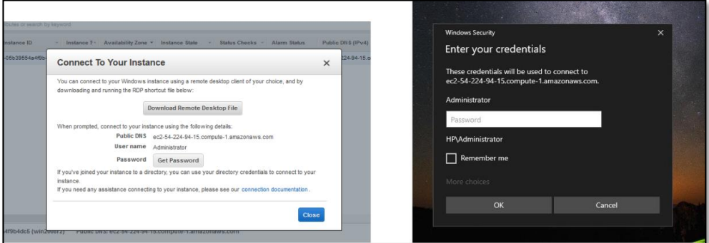

Copy the password and paste it in the windows dialog box administrator password

